Calculate , , and by hand

Lab manual ke mutabiq:

Start: S

Goal: G

Formula:

: Start se current node tak actual cost.

: Current node se goal tak estimated cost.

: Actual cost + estimated remaining cost.

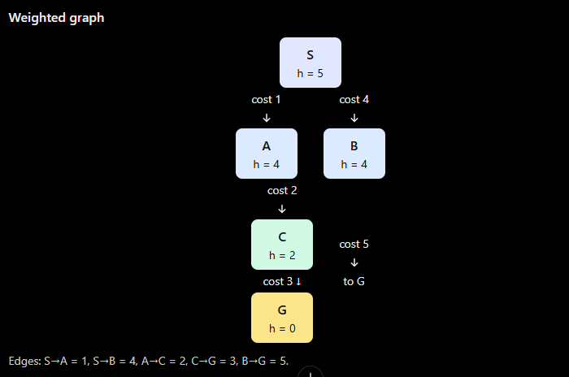

1 — Select S
- Initially, the frontier contains only S.

- \[ f(S)=g(S)+h(S)=0+5=\boxed{5} \]
- Expand S and calculate the values for its successors:
- For A:

- \[ f(A)=1+4=\boxed{5} \]
- For B:

- \[ f(B)=4+4=\boxed{8} \]
- Frontier after expanding S:
Node | g | h | f
A | 1 | 4 | 5
B | 4 | 4 | 8
- Why is A selected next? A has the lowest -value: .

Expansion 2 — Select A
- For A:

- \[ f(A)=1+4=\boxed{5} \]
- Expand A. Its successor is C.

- \[ f(C)=3+2=\boxed{5} \]
- Frontier after expanding A:
Node | g | h | f
C | 3 | 2 | 5
B | 4 | 4 | 8
- Why is C selected next? C has , which is lower than B's .

Expansion 3 — Select C
- For C:

- \[ f(C)=3+2=\boxed{5} \]
- Expand C. Its successor is G.

- \[ f(G)=6+0=\boxed{6} \]
- Frontier after expanding C:
Node | g | h | f
G | 6 | 0 | 6
B | 4 | 4 | 8
- Why is G selected next? Because is lower than . G is the goal, so the search returns the route.
- The first three selected nodes are S, A, C. The next selected node is G.

